Macroeconomic Overview of the United States of America
Name
Institutional affiliation
Date

Introduction
To evaluate the performance of an economy within a country, it is important to carry out a macroeconomic analysis. A macroeconomic analysis involves the evaluation of macroeconomic indicators such as unemployment, GDP, level of interest rates, monetary policies, and retail sales among others. These indicators show the performance of the economy over different time periods, which could be used in evaluating the future performance of the economy. One of the performing economies in the world is the United States. The current task analyzes the US economy under the different macroeconomic indicators such as inflation, unemployment, GDP levels, and interest rates.
Overview of the US economy
The US economy is considered the largest and one of the most relevant economies across the world. The global landscape is transforming rapidly and despite such challenges, the US economy has continued to perform against other economies across the world. The economy of the US denotes close to 20% of the total output globally and continues to be higher than the Chinese economy. The manufacturing and service industries make up to 80% of the total output. The complex US economy is characterized by significant natural resources, high level of technology, and equipped physical infrastructure. In addition, the US economy is also characterized by a highly trained workforce thus creating a highly competitive economy. Analysis of the different macroeconomic indicators over the past 10 years will provide an overview of the performance of the US economy over these years (Ahuja, 2015, p. 40).
Data Collection Methods
For the purposes of this research, data was collected from the Federal Reserve Economic Data (FRED) website. The FRED website is a database that is under the Research department of the Federal Reserve Bank of St. Louis. The data will be collected over the period of 10 years. The data from the website has been provided in graphical form and can be imported to a word document. The imported data is then analyzed used the economic theories learned through the course.
Unemployment
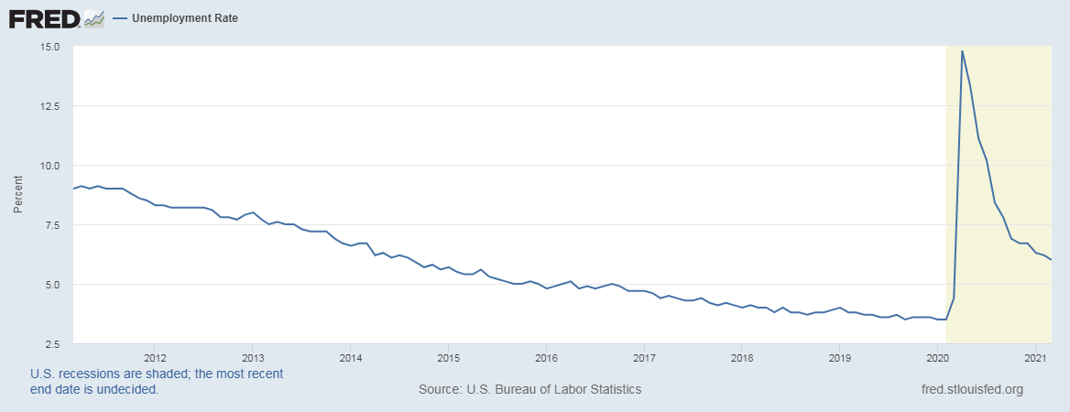
Figure 1: unemployment rate (2011- 2021)
Unemployment rate refers to the percentage of the people who are within the labor force but do not have an actual job. The unemployment rate is considered an indicator of the performance of the economy. When the economy is performing positively, it implies that jobs are in plenty, which leads to low levels of unemployment rate (Mankiw, 2019, p. 485). The same happens when the economy is performing negatively where the jobs are scarce and there are more people who are unemployed. According to the data provided, the unemployment rate has been falling since 2011, which implies of the positive performance of the US economy over these years. However, there was a sharp increase in the unemployment rate in February 2020 due to the Covid 19 pandemic. By April 2020, the unemployment rate was at an all-time high of 14.8%. At this time, and there was a sudden halt in economic activity due to the pandemic, which rendered many people jobless. As of March 2021, the unemployment rate had fallen to 6.0, which explains a recovery in the economic output in the United States (stlouisfed.org., 2021).
Inflation Rate
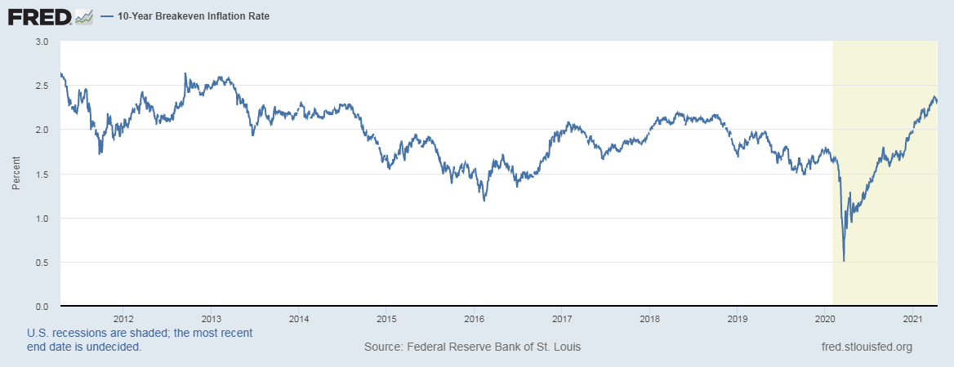
Figure 2: Inflation Rate in the United States (2011-2021)
In macroeconomics, inflation refers to the decline in the purchasing power of a specific currency over time. When there is a general increase in price of commodities, it implies that a unit of the currency buys fewer commodities than it could have bought in earlier times (Mankiw, 2019, p. 479). The Federal Reserve has set 2% as the target level of inflation rate that which maintains the economic performance of the country. According to the data, there was a staggering rate of inflation over the ten years, with some years recording low levels below 2% target and others recording higher than 2%. Notably, these fluctuations have not been far from the target until March 2020 when the inflation rate hit its lowest rate, 0.5%. The low level can be attributed to the Covid pandemic, which rendered many people jobless (stlouisfed.org., 2021). With a high rate of unemployment due to the pandemic, the demand for products and services was low, which was an indicator of a slowed growth in the economy. Over the past few months, the inflation rate has been gradually increasing, which implies of a slow increase in economic growth. Since the opening up of the economy, there has been an increase in economic activity, which also has led to increase in consumer spending, thus the gradual increase in inflation rate (Ahuja, 2015, p. 66).
Gross Domestic Product (GDP)
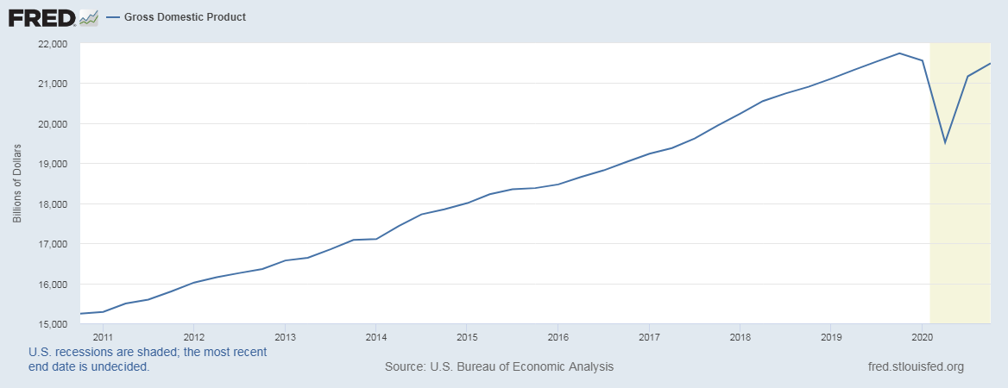
Figure 3: GDP of the United States (2011-2021)
The nominal GDP evaluates the total output of an economy with the application of the existing prices, without making any adjustments for inflation. The nominal GDP is considered as the actual monetary value of the total goods and services from a country within a specific period. The major difference between the real and nominal GDP is that the real GDP makes inclusion of the price changes due to the aspect of inflation thus showing the price changes within an economy (Mankiw, 2019, p. 483). According to the data provided, the US`s nominal GDP was increasing at a higher rate, from $15,000 billion in 2011 to $21,000 billion in 2019. However, the total output started decreasing towards the end of 2019 and dipped further during the first two quarters of 2020 to about $19,000 billion (stlouisfed.org., 2021). Towards the third quarter of 2020, the GDP sharply rose again and has since been gradually increasing to the levels before the pandemic. Such changes were due to the Covid pandemic, which saw the closing down of major industries such as the hospitality industry among other service industries, which contribute immensely to the GDP of the economy within the United States. Notably, the GDP levels did not dip to unmanageable levels where the GDP at the height of pandemic was similar to the level of GDP in 2017. Such an observation explains the strength of the economy in spite of the short term disruption in the economic activities (Ahuja, 2015).
Interest Rate

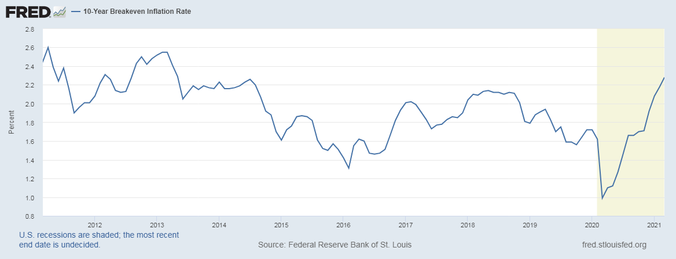
Interest rates refer to the proportioned amount that a lender will charge as the interest for the money borrowed. The level of interest rates within an economy is determined by the monetary policies adopted by the government. When interest rates go up, it becomes more costly to borrow thus lowering the demand for loanable funds. Less demand for loanable funds implies low investments and reduced consumption, which leads to reduced economic activity. On the other hand, if the interest rates go down, it becomes easier to borrow money, which improves the demand for loanable funds. When there is a demand for loanable funds, there is an increase in investments and consumption, which leads to an improvement in economic activity. According to the data, the interest rates have been fluctuating from high to low but ranging between 1.31% and 2.55%. However, the Covid pandemic led to the lowest point of 0.99% due to the economic inactivity of the country after the major economic activities were halted to prevent the spread of the disease (stlouisfed.org., 2021). However, the interest rates have since been increasing as consumer spending increases due to increased economic activity, and reduced unemployment rates (Mankiw, 2019, p. 481). It is expected that in the coming few months, the interest rates will get back to their normal rates so as to sustain the recovering economy.
Conclusion
From a general observation, the economy of the United States has been stable over the past ten years. With a consistent reduction in the level of unemployment, fluctuating but normal interest rates, a constant inflation rate, and a steady increase in the level of GDP all point to economic improvement. However, all these improvements were disrupted by the Covid pandemic, which saw a major decline in economic activities due to the lockdowns and the curfews. Given that some industries were closed, unemployment went high, which also led to the reduction of demand for consumer goods. A notably low interest rate led to reduced demand for loanable funds. All these changes led reduction in demand of goods thus the low inflation rates and poor economic growth. As the restrictions continue to ease, there has been a notable improvement in economic activity and with the introduction of vaccine and opening up the economy; the economy is expected to continue with its course.

References
Ahuja, H. L. (2015). Macroeconomics. S. Chand Publishing.
Mankiw, N. G. (2019). Macroeconomics. Worth Publishers.
stlouisfed.org., (2021). Interest Rates. Retrieved from https://fred.stlouisfed.org/series/T10YIEM
stlouisfed.org., (2021). Gross Domestic Product. https://fred.stlouisfed.org/series/GDP
stlouisfed.org., (2021). inflation rate. https://fred.stlouisfed.org/series/T10YIE
stlouisfed.org., (2021). Unemployment Rate. https://fred.stlouisfed.org/series/UNRATE

